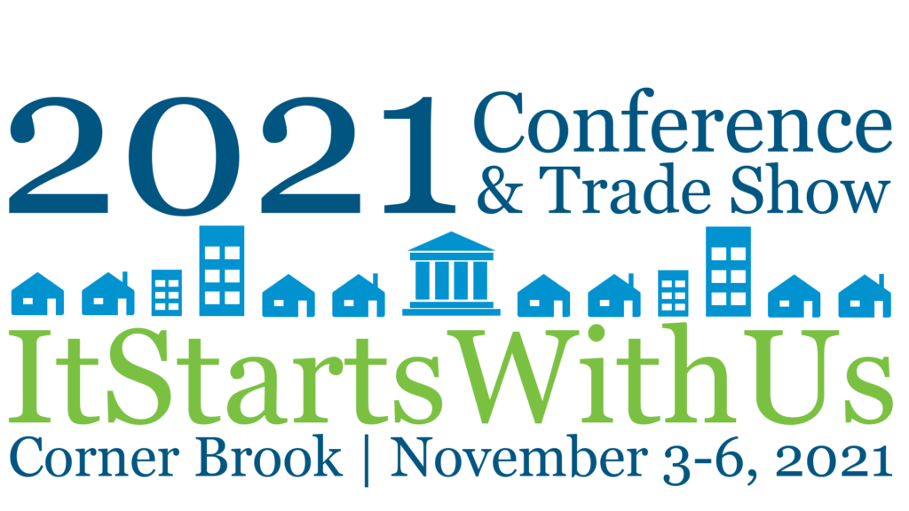
Climate Resilience: Resources and Information for Municipalities
MNL Conference Session Takeaways

What needs to be done (and when)?
Some of this will rely on the Conference of the Parties (COP) outcomes, but there are a lot of ideas out there already! Some potential directions and groups to watch here:

The Net-Zero Advisory Body (NZAB) was established by the Minister of Environment and Climate Change in 2021 “…to provide independent, constructive, and forward-looking advice on pathways to achieve net-zero emissions by 2050”. NZAB released “Net Zero Pathways: Initial Observations” in June
(visit https://bit.ly/2ZwFxvL )

Canadian Institute for Climate Choices – Their 2021 report, “Canada’s Net Zero Future: Finding our way in the global transition” offers a cross-cutting economic “…analysis of Canada’s options, significant drivers within and outside of Canada’s control, and the conditions that are likely to influence success” in meeting Canada’s 2050 net zero greenhouse gas emissions target.”
(see https://climatechoices.ca/reports/canadas-net-zero-future ). Together with NZAB, they delivered a virtual conference on October 25th titled, “Canada’s Net Zero Economy: Securing Prosperity in a Net Zero World” (details at https://netzeroeconomy.ca/ )

The Canada Climate Law Initiative’s ( http://ccli.ubc.ca/knowledge-hub/resources-for-policy-makers )
ongoing research aims to improve climate policy outcomes based on this simple notion: When actors improve their understanding of the networks in which they operate, they also improve their chances of discovering new ways to coordinate their efforts with others. In turn, better coordination results in better outcomes, which equals faster decarbonization. Check out their video: https://www.youtube.com/watch?v=EvLfPbpBPh4&t=1s

The Climate Caucus (CC) is a growing non-partisan network of local elected climate leaders seeking to drive system change to transform their communities in ten years. Collectively, they are aiming to create and implement 21st century socially-just policy which aligns with the Intergovernmental Panel on Climate Change (IPCC), Intergovernmental Science Policy Platform on Biodiversity and Ecosystem Services (IPBES), and the United Nations Declaration on the Rights of Indigenous Peoples (UNDRIP). Visit https://www.climatecaucus.ca for more information. Their Atlantic Municipalities Working Group has just been launched.
Finally (and closer to home), a new paper - “The Long and Short of Food Security on the Great Northern Peninsula: Moving the Needle Toward a More Local Plate” by Memorial’s Grenfell Campus research team led by Ivan Emke ( iemke@grenfell.mun.ca ), responds to a key, food security question, “What can municipalities do about promoting food production?“ Dr. Emke’s paper and the Executive Summary of the associated final social enterprise research project report - “Spiraling Upwards” Mobilizing Community Capital” are both available at https://foodnotes.ca/assorted-writings

Where to look for help with local climate change action?
Here are some key organizations, programs and tools to be aware of.

Nationally

The Federation of Canadian Municipalities (FCM) have a wealth of information and program resources on a variety of climate change action fronts. Start at their terrific portal - https://fcm.ca/en/resources – to search by topics (e.g. “asset management”, ”climate change”, “sustainability”) and resources (including articles, case studies, toolkits and guides). Also use the portal to look up these FCM Programs:
- The Partners in Climate Protection (PCP) Program is managed and delivered by the FCM and ICLEI – Local Governments for Sustainability Canada. Their five-milestone framework helps municipalities (1) create a GHG inventory and forecast; (2) set emission reduction targets; (3) develop a Local Action Plan; (4) implement the Local Action Plan; and, (5) monitor and evaluate progress. The program provides numerous on-line instructional activities and resources, including the PCP Milestone Tool ( https://pcptool.ca ) - a web-based, user-friendly means available to PCP members to quantify, monitor and manage locally-generated GHG emissions.
- Municipalities for Climate Innovation Program (MCIP): Great climate change action-related funding, training and other resources.
- *New* Sustainability Staff series including the “Guide for Municipal Climate Change Staff” and “Financing Tools for Local Climate Action”.
- Municipal Asset Management Program (MAMP): Advancing climate resilience through the practice of asset management is getting greater attention as the current Gas Tax Agreement nears its end and towns across the country work towards implementing their required asset management plans. This program also engages other important national organizations of note, such as the Canadian Network of Asset Managers (CNAM).

The Government of Canada launched the Canadian Centre for Climate Services (CCCS – check out their website) in October 2018, and as part of the program’s mandate, began supporting the establishment of regional hubs to build capacity across the country and provide access to localised information and support needed to make communities and the economy more resilient to the impacts of climate change. The latest of these regional hubs is CLIMAtlantic which will facilitate access to regionally-relevant climate information and supports its effective use in planning and decision making for all of New Brunswick, Nova Scotia, Prince Edward Island and Newfoundland and Labrador. Watch for news of the official launch of our CLIMAtlantic hub soon!

The Nature Conservancy of Canada (NCC) is the only land trust organization in Newfoundland and Labrador. The NCC has helped protect 5,600 hectares (over 13,800 acres) of some of the best wilderness in the province. NCC currently owns land in nine project areas across the island, which include riparian, forested, and wetland areas. They are always open to new partnerships to explore ways to enact conservation in communities across the province – conservation that makes meaningful differences in preserving biodiversity, and that can be beneficial in preparing for climate change. To learn more, please visit https://www.natureconservancy.ca

Provincially

The Climate Change & Resilient Infrastructure (2018-22) project, funded by NRCan and led by Dr. Joe Daraio of Memorial University’s Faculty of Engineering, aims to build and sustain infrastructure resilience through targeted climate adaptation training for professionals in Newfoundland and Labrador. The final CCRI workshop is scheduled for February 22-24th, 2022. For the history of this project and archived prior Climate Resilience workshop series, visit:
https://www.engr.mun.ca/CCRI/home/our-projects/nrcan/workshops-training/

Conservation Corps Newfoundland and Labrador (CCNL) is a non-profit organization designed to serve youth and communities throughout the province. CCNL supports local priorities in the areas of environmental and cultural conservation through:
• subsidized youth employment programming;
• climate change education; and
• capacity building projects which enable municipalities to address and mitigate climate change impacts to build more resilient communities.
If you’d like to know more about what they do and how they can serve your community, please visit www.ccnl.ca or contact Megan Stuckless at mstuckless@ccnl.ca

The Stewardship Association of Municipalities (SAM) supports their member communities in the conservation and stewardship of important wildlife habitat across Newfoundland and Labrador. The organization works with the Eastern Habitat Joint Venture in NL to secure, enhance, & restore wetlands, uplands, coastal areas, & species at risk habitat within municipal planning boundaries. As a network of communities who practice environmental stewardship, SAM contributes to maintaining & enhancing biodiversity in the province. Visit https://www.samnl.org for more information.

econext (formerly NEIA) is an association of businesses that accelerates clean growth in Newfoundland and Labrador (visit https://econext.ca ). The association works on behalf of over 200 members to foster environmentally sustainable economic development by focusing its activities and initiatives on providing:
- a support framework for entrepreneurs and startups;
- networks to help increase productivity and competitiveness;
- tools to encourage and foster innovation;
- export and international business development programming;
- training and professional development opportunities to build capacity; and,
- leadership on policy and advocacy issues

The Western Environment Centre ( www.wecnl.ca ) – based in Corner Brook - has a mission to engage, educate and interact with their community in food and climate action. The WEC aims to inspire environmental action and conversation through hands-on projects, public events, and policy dialogue.
WEC programs include five community gardens, three community compost projects, a fruit rescue program, and food skills & green living workshops. Their Green Drinks Speakers Series provides critical conversation on topics such as oil and gas, sustainable food systems, aquaculture, and more. Contact Katie Temple at info@wecnl.ca for more information.

FoodFirstNL works with communities in Newfoundland & Labrador to ensure everyone has access to affordable, healthy, and culturally appropriate food. We raise awareness, strengthen partnerships, and catalyze action across all five areas of the food system: production, transportation, access, consumption, and disposal. Visit https://www.foodfirstnl.ca for additional information.

Where to start…? What does municipal “action” on climate change look like?
A few ideas on entry points and related resources and links to be aware of…

Have a plan – or two or three!
Check to see what bits and pieces of a local Climate Change Action Plan you may already have.

- Asset Management Plan (AM): The contemporary practice of asset management is new to most communities in NL but, under our current Gas Tax agreement, all municipalities in the country must bring it into effect by 31 March 2023 – just 17 months away now. Have you started your AM Planning yet? Now’s the time! Among other things, AM ensures that climate change risks will be taken into account in your infrastructure planning and investments. The Province’s AM toolkit is expected to be officially released in 2022 but is available on request now. The other key resource to start with is the FCM’s Asset Management Readiness Scale – a fillable version to maintain for your town can be signed into on the MNL website.
- Sustainability Plan: Have you read your Integrated Community Sustainability Plan? ICSPs were to identify key local sustainability goals and develop the road map to meeting them. They were a requirement under an earlier Gas Tax agreement. Have a look for yours and see if it needs an update. Many communities elsewhere in Canada are into their third iterations of these plans.
- Municipal Land Use Plan and Development Regulations: Only about half of our 275 incorporated municipal and ICG governments have these but if your community is one of them, you have an opportunity to employ your development control policy to support your climate change action plans.

Then get to work if you discover there are gaps! Here are some next-step ideas:

- Climate Change Risk and Vulnerability Assessment: Climate changes in NL are in evidence in every season of the year and in the increasing frequency and intensity of extreme weather events. Still, these changes vary from region to region and while their impacts will be experienced similarly by many communities, adapting to them is different for every community. There is a highly recommended tool for undertaking these assessments that was developed here in the province: Check out the fillable version of the “7 Steps to Assess Climate Change Vulnerability in Your Community” toolkit available in the MNL website Resources section.
- GHG Emissions Inventory: Municipalities can lead the way by modeling the ways that we all mitigate future climate change. Whether through the FCM’s Partners for Climate Protection Program (PCP) or a project with otherwise, more and more towns here are pursuing these.
- Local Food Security Action: The WEC, FoodFirstNL, farmers, foragers and thoughtful consumers have been doing a lot of work on improving our access to locally-produced foods over the last decade. Buying and eating local products is something that every person and municipality can do to reduce their carbon footprint. Whether it’s starting a community garden, a composting effort, a farmers’ market or food rescue project, or helping young farmers get established, there are all kinds of opportunities for municipalities to get involved.
- Other local initiatives are emerging all the time. Keep an eye out for news on the Community Currents for Climate (C³) project that MNL is a partner to. It’s a school-based, citizen-science program engaging grade school students and teachers in local watershed monitoring activities. Two schools are piloting this program currently in partnership with the Towns of Lawn, Bauline and Torbay. Watch for a call for additional community participants in 2022. In the meantime, for more information contact Dr. Kathleen Parewick at kparewick@municipalnl.ca or call (709) 728-8393.

